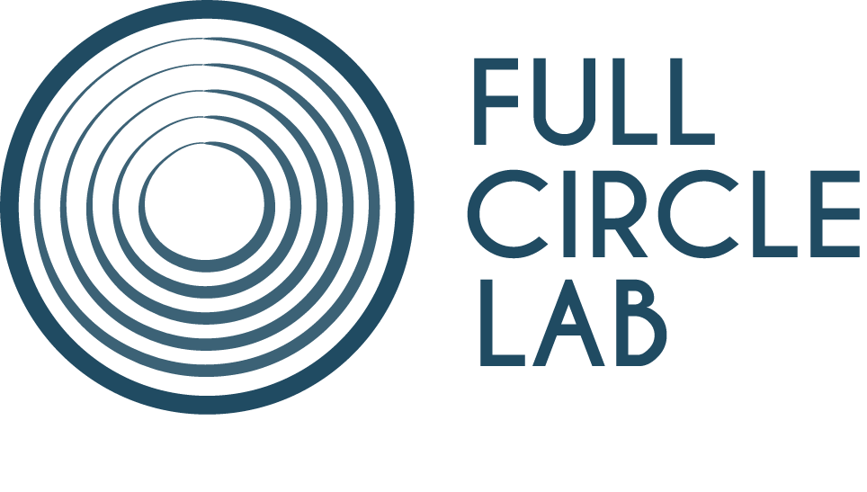

FULL CIRCLE LAB UPPER RHINE 2020

Deadline: October 15th, 2019

APPLICATION FORM

Information about the project

TITLE:

Production company
Name:
Address:
Website:

Information about the applicants

Director
First Name:
Last Name:
Nationality:
Email:
Phone:

Scriptwriter
First Name:
Last Name:
Nationality:
Email:
Phone:

Producer
First Name:
Last Name:
Nationality:
Email:
Phone:

Connection of the project with the Upper Rhine Area

– the scriptwriter or the director are residents in the Upper Rhine area;
YES / NO

– the production company is established and active in the Upper Rhine area;
YES / NO

– the feature film project is strongly connected to the Upper Rhine area, with clear potential for production and/or shooting to take place in the area.
YES / NO

Please explain:

Materials to submit

Please email the following materials combined into a single PDF document
(in English, AND in either French or German) to upperrhine@fullcirclelab.org

– The completed application form
– A 1-page synopsis
– A 10-page treatment or a script
– An intention note
– Biographies of the scriptwriter and producer
– A profile of the production company
– Web links to previous films – if any.

