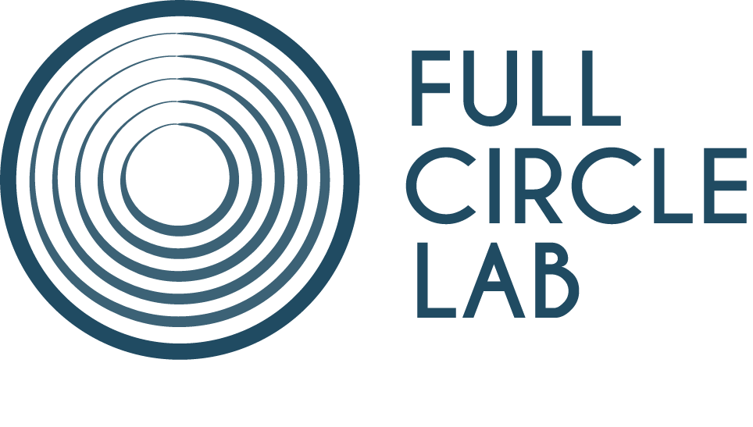

FULL CIRCLE LAB NOUVELLE-AQUITAINE 2022

Development Lab | deadline: July 1st, 2022

APPLICATION FORM

Information about the project

TITLE:

Production company
Name:
Address:
Website:

Information about the applicants

Director
First Name:
Last Name:
Nationality:
Email:
Phone:

Scriptwriter
First Name:
Last Name:
Nationality:
Email:
Phone:

Producer
First Name:
Last Name:
Nationality:
Email:
Phone:

Connection of the project with the Nouvelle-Aquitaine Region

- Authors/directors from Nouvelle-Aquitaine, with a project that benefited from national/regional selective grants or who reached plenary commission for a regional funding request;
YES / NO

- Producers from Nouvelle-Aquitaine, with a project that benefited from an international, national or regional selective grant;
YES / NO

- Projects supported by the Region or by the appointed departments;
YES / NO

- Projects supported in the context of festivals (the clos-FIFIB, the Biarritz Bal Lab, the Poitiers Film Festival residencies) and partner residencies (La Prévôté, Chalet Mauriac, La Maison Bleue, Atelier Claude Miller).
YES / NO

Materials to submit

Please email the following materials combined into a single PDF document
(in English, OR in French) to nouvelle-aquitaine@fullcirclelab.org

– The completed application form
– A 1-page synopsis
– A 10-page treatment or a script
– An intention note
– Biographies of the scriptwriter and producer
– A profile of the production company
– Web links to previous films – if any.

